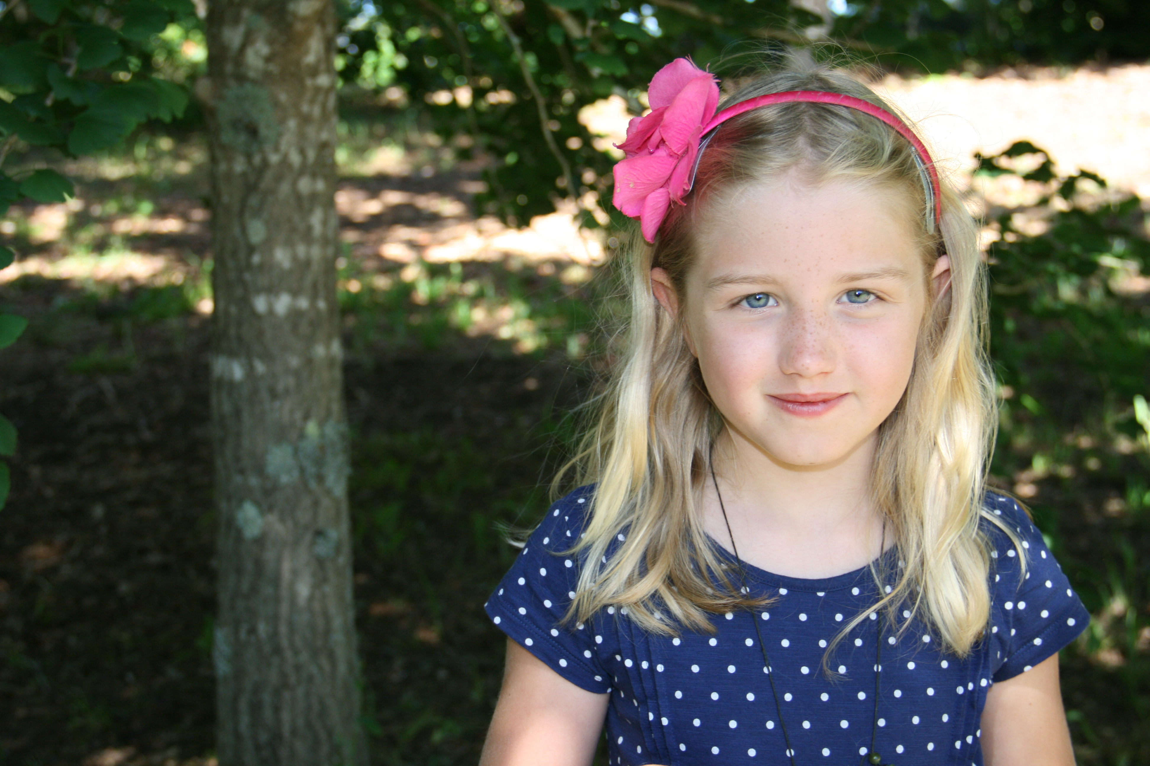
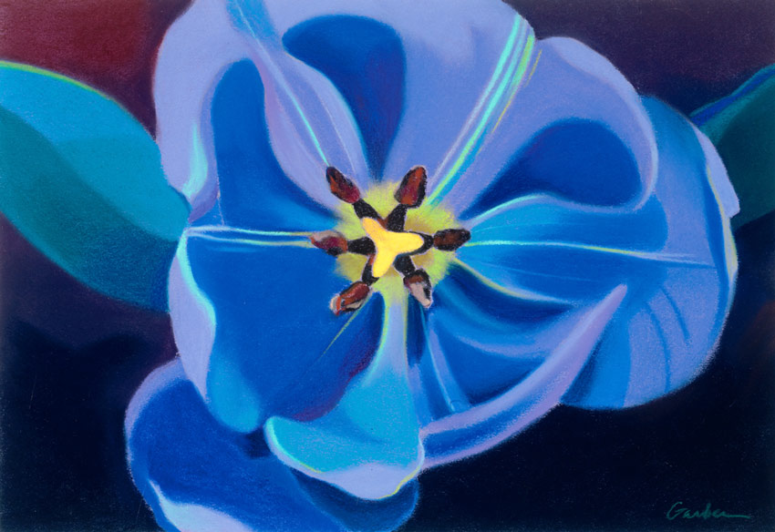

Kind, intelligent and friendly
Sibling of annoying little brother
Lover of dogs, cats and chocolate.
Who feels sad when you get pushed around.
Who feels happy when you eat chocolate.
Who feels funny when I am tickled.
Who gives friendship, books and love.
Who fears swimming beside sharks, deep water and getting chased by a bull.
Who would like to see a Tropical Island, whales and rare flowers.
Who lives down Inlet Road.

